The 5 Whys
- Identify problem(s) during Comprehensive Needs Assessment
- Brainstorm a possible cause of the problem, why the problem was not detected, and what systems failed
- Ask “WHY” until you determine the root cause (Example Problem: Reading scores are decreasing in intermediate grades. WHY? Because RTI procedures are not followed. WHY? Because the procedures haven’t been communicated effectively? WHY? Because staff has not all been trained. WHY? etc.)
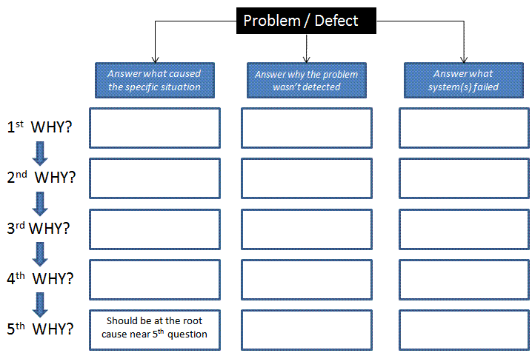
- Come to consensus about the ultimate root cause

Answer what caused the specific problem.

Problem
Answer what system(s) failed.
Answer why the problem wasn’t detected.

