Affinity Mapping
- Identify problem(s) during Comprehensive Needs Assessment
- Brainstorm possible root causes
- Categorize possible causes
- Focus on the Programmatic and Systemic causes - Incidental and External problems are less in the school’s control
Come to consensus about the ultimate root cause.
Examples: family, gangs, community
Examples: a single student, test, teacher, or event

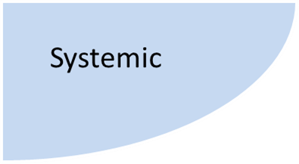
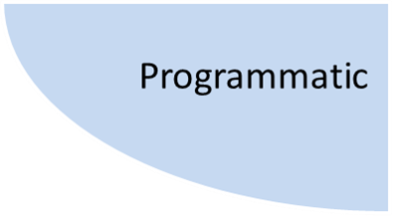
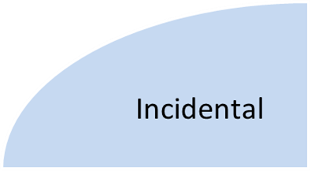
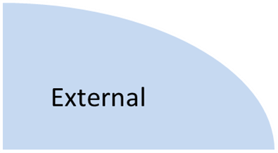

Examples: schoolwide procedures, instructional processes, curriculum, training
Examples: school culture, priorities, leadership, mission/vision

Verify that your explanation is a Root Cause by discussing the following questions:
- What proof do I have that this cause exists? (Is it concrete? Is it measurable?)
- What proof do I have that this cause could lead to the stated effect? (Am I merely asserting causation?)
- What proof do I have that this cause actually contributed to the problem I’m looking at? (Even given that it exists and could lead to this problem, how do I know it wasn’t actually something else?)
- Is anything else needed, along with this cause, for the stated effect to occur? (Is it self-sufficient? Is something needed to help it along?)
- Can anything else, besides this cause, lead to the stated effect? (Are there alternative explanations that fit better? What other risks are there?)

