Future Planning Activity
The preferred future chart can be used as a tool to help the decision-making processes as the school moves toward learning improvement goals.
By beginning with the end in mind, schools can design a future that includes systemic improvement that impacts every student in the school, bridging the gap between what is actually happening, and what they want to happen in the future.

Action Steps to Support Goals
Either do this in small groups or project to use with full team. Directions for the chart:
- Write an abbreviated version of your goal in the preferred future space, such as “increase math scores by 25% by 2018.”
- Write the current reality in the square box, such as, “55% not meeting in math.”
- List as many potential improvement activities as possible, making sure they relate directly to the improvement target.
- When each line is filled in, evaluate the possibilities by asking the following questions: Is this activity research-based? Is it doable? Do we have the time and resources? Use the Thinking It Through Worksheet to help you develop action steps.
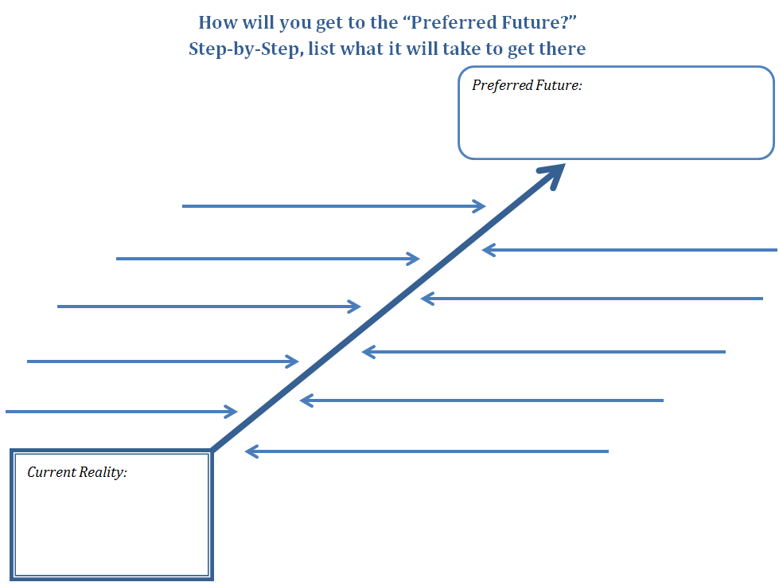

How will you get to the “Preferred Future?”

Step-by-Step, list what it will take to get there
Preferred Future:
Current Reality:

